HTML5 and CSS3 assignment:

Create a web page with HTML5 and CSS3:

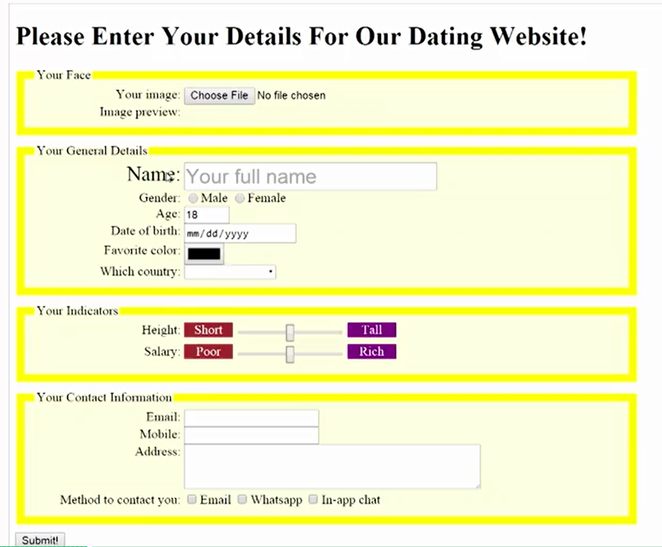

Requirement:

Create four groups. These all field set with legend.

Group example:

<form>

<fieldset>

<legend>Personal Information</legend>

First name? <input type="text" name="firstName"> <br>

Last name? <input type="text" name="lastName"> <br>

</fieldset> <br>

<fieldset>

<legend>Favourite Things</legend>

Favourite cartoon? <input type="text" name="favCartoon"> <br>

Favourite pizza? <input type="text" name="lastName"> <br>

</fieldset> <br>

</form>

1. Your face section:
   1. Handling file upload: <input type=”file”>, you should be able to preview the uploaded image on the web page.
   2. Same as uploading a image, upload audio and video on the page (Bonus points)
2. Your General details:
   1. Show “your full name” in the textbox as the tooltip
   2. Gender
   3. For Age, use a number input field as a spinner which you have up and down arrow at the right of the textbox to increase or decrease the number value (Hint: input type: Numbers)
   4. For Date of birth field, see below: (Hint: input type: Date)



* 1. Favorite color: click on the color box, it should show the color picker on the page.

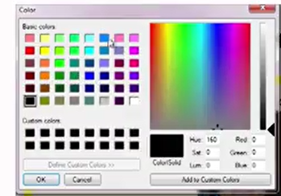

* 1. Which county: it will show a list of countries in the drop down. You can hardcode some values. (hint: input Attr datalist)

1. Your indicators:
   1. Height and Salary should be sliders. (Hint: input type Range)
2. Your contact information:
   1. It should have Email, Phone and Address
   2. Method to contact to you.
3. Validation requirement:
   1. Make all the input fields as required fields. (Hint: input Attr: Required)
   2. While typing in the email input, validate if it is a valid email address. (Hint: Input type: Email)
   3. While typing in Phone input, only numbers are allowed (Hint: Input type: Phone)
4. Style requirement:
   1. For each group, highlight the border and make the background color to light yellow.
   2. If you mouse over the labels or the input controls, they will get larger. (see “Name” and name textbox in the screenshot above)
   3. Be creative, create your own style and make the web page look great! (Bonus points)